**Pasta Dishes**

**Spaghetti Aglio E Olio**

**Recipe courtesy of Ina Garten**

[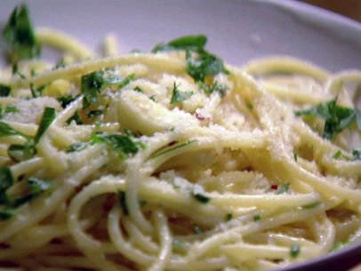](http://www.foodnetwork.com/recipes/ina-garten/spaghetti-aglio-e-olio-recipe.print.html#lightbox-recipe-image)

Total Time:35 min

Yield: 4 servings

**Ingredients**

* Kosher salt
* 1 pound dried [spaghetti](http://www.foodterms.com/encyclopedia/spaghetti/index.html), such as DeCecco
* 1/3 cup good olive oil
* 8 large [garlic cloves](http://www.foodterms.com/encyclopedia/garlic/index.html), cut into thin slivers
* 1/2 teaspoon crushed [red pepper flakes](http://www.foodterms.com/encyclopedia/red-pepper-flakes/index.html)
* 1/2 cup minced fresh [parsley](http://www.foodterms.com/encyclopedia/parsley/index.html)
* 1 cup freshly grated [Parmesan cheese](http://www.foodterms.com/encyclopedia/parmigiano-reggiano/index.html), plus extra for serving

**Directions**

Bring a large pot of water to a boil. Add 2 tablespoons of salt and the pasta and cook according to the directions on the package. Set aside 1 1/2 cups of the pasta cooking water before you [drain](http://www.foodterms.com/encyclopedia/drain/index.html) the pasta.

Meanwhile, heat the [olive oil](http://www.foodterms.com/encyclopedia/olive-oil/index.html) over medium heat in a pot large enough to hold the pasta, such as a 12-inch sauté pan or a large, shallow pot. Add the garlic and cook for 2 minutes, stirring frequently, until it just begins to turn golden on the edges-don't overcook it! Add the red pepper flakes and cook for 30 seconds more. Carefully add the reserved pasta-cooking water to the garlic and oil and bring to a boil. Lower the heat, add 1 teaspoon of salt, and [simmer](http://www.foodterms.com/encyclopedia/simmer/index.html) for about 5 minutes, until the liquid is reduced by about a third.

Add the drained pasta to the garlic [sauce](http://www.foodterms.com/encyclopedia/sauce/index.html) and toss. Off the heat, add the parsley and Parmesan and toss well. Allow the [pasta](http://www.foodterms.com/encyclopedia/pasta/index.html) to rest off the heat for 5 minutes for the sauce to be absorbed. Taste for seasoning and serve warm with extra Parmesan on the side.

2010, Barefoot Contessa How Easy is That?, All Rights Reserved

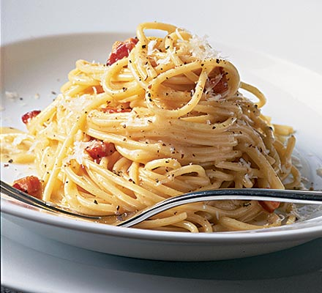**Spaghetti Carbonara**

**Ingredients:**

* 8 oz. spaghetti
* 4 slices of bacon, cut into ½ inch cubes
* ¼ cup chopped onion
* 1 clove garlic
* 2 eggs, beaten
* ¼ cup parmesan cheese
* ¼ tsp. salt
* ¼ tsp. pepper

**Directions:**

1. Boil pasta for 8-10 minutes.
2. While pasta is boiling, fry bacon.
3. When bacon is nearly cooked, add garlic and onions.
4. In a small bowl mix eggs, cheese, salt and pepper.
5. Drain pasta, put back in pot.
6. Add egg mixture to hot pasta.
7. Stir until egg is cooked.
8. Stir in bacon mixture.
9. Serve immediately.

**Fettuccine with Asparagus and bacon**

½ asparagus or broccoli

2 Tablespoons unsalted butter

1 Tablespoon olive oil

1 green onion, sliced

2 oz bacon or prosciutto, cut into strips (ham works too)

4 oz heavy cream

Salt and black pepper

½ lb. fettuccine

Parmesan, grated

1. Cook pasta in a large pan of boiling water, until al dente.
2. Cut asparagus spears into 1 inch pieces. Heat butter and oil in a large skillet, add green onions, and cook for 2 minutes to soften, stir in bacon (prosciutto). Cook for 2 minutes, add asparagus and cook for 5 minutes, until softened. Pour in cream and bring to the boil, season to taste.
3. Drain pasta but keep some pasta water. Add pasta to sauce in fry pan and add pasta water to thin down sauce if needed.

Serves 4

**Chicken Fettuccine Alfredo**

**2 People: Chicken**

1 or 2 boneless skinless chicken breasts

Olive oil

Salt, pepper, garlic **to taste**

Cut chicken breast into chunks or strips. Season chicken pieces as desired. Heat skillet, add olive oil and seasoned chicken. Fry on medium heat until cooked…don’t over cook your chicken!

**2 people: Sauce and Noodles**

¼ cup butter

¾ cup heavy cream

½ cup Parmesan cheese

Salt, pepper, garlic **to taste**

Melt butter in saucepan; add cream and ¼ cup of the cheese. Cook over low heat stirring constantly. Do not boil

½ lb. fettuccine noodles (1/2 box)

Cook fettuccine in 3 quarts boiling water. Drain cooked noodles. Combine sauce, cooked chicken and ¼ cup Parmesan cheese over cooked drained noodles and enjoy.